License Token

📜 What Is a License Token?
# Source: AI Source: Provided by: [Data Path: Persons Table -> ID Column: 1, Name_En Column: Motasem Essam] -> From: [ChatGPT] on [1/18/2026]
A License Token is a digital key or token that is used to verify that a user or application has a valid license to use a particular product, service, software, or feature.

✅ Simple Definition:
# Source: AI Source: Provided by: [Data Path: Persons Table -> ID Column: 1, Name_En Column: Motasem Essam] -> From: [ChatGPT] on [1/18/2026]
A License Token proves that someone is allowed to use a piece of software or feature — like a digital "receipt" or access pass for a paid or restricted service.

🧠 Real-Life Analogy:
# Source: AI Source: Provided by: [Data Path: Persons Table -> ID Column: 1, Name_En Column: Motasem Essam] -> From: [ChatGPT] on [1/18/2026]
Think of it like a subscription receipt for a streaming service:
- Your account is linked to a subscription
- The app receives a token that confirms you paid
- The app then lets you watch content — as long as the token is valid

🔐 Where It's Used
# Source: AI Source: Provided by: [Data Path: Persons Table -> ID Column: 1, Name_En Column: Motasem Essam] -> From: [ChatGPT] on [1/18/2026]
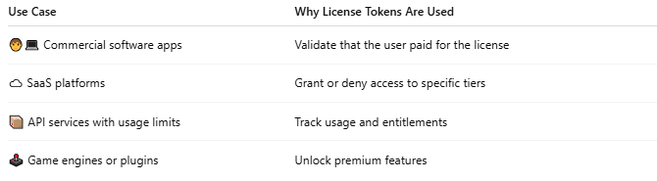

Use Case | Why License Tokens Are Used
🧑‍💻 Commercial software apps | Validate that the user paid for the license
☁️ SaaS platforms | Grant or deny access to specific tiers
📦 API services with usage limits | Track usage and entitlements
🕹️ Game engines or plugins | Unlock premium features

🔄 How It Typically Works
# Source: AI Source: Provided by: [Data Path: Persons Table -> ID Column: 1, Name_En Column: Motasem Essam] -> From: [ChatGPT] on [1/18/2026]
- User buys a license or subscription
- Server issues a license token (signed or encrypted)
- Client stores the token or gets it via API call
- On each app launch or feature use:
  - Token is verified with the license server
  - If valid → feature is unlocked

📦 Example License Token (JWT Style)
# Source: AI Source: Provided by: [Data Path: Persons Table -> ID Column: 1, Name_En Column: Motasem Essam] -> From: [ChatGPT] on [1/18/2026]
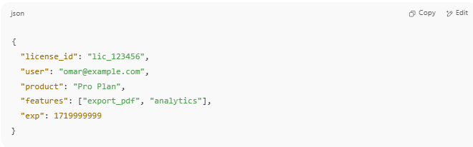
{
"license_id": "lic_123456",
"user": "omar@example.com",
"product": "Pro Plan",
"features": ["export_pdf", "analytics"],
"exp": 1719999999
}

This could be encoded as a JWT, encrypted blob, or simple string.

✅ License Token vs API Token
# Source: AI Source: Provided by: [Data Path: Persons Table -> ID Column: 1, Name_En Column: Motasem Essam] -> From: [ChatGPT] on [1/18/2026]
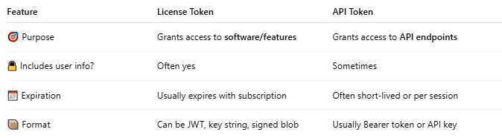

Feature | License Token | API Token
🎯 Purpose | Grants access to software/features | Grants access to API endpoints
🔒 Includes user info? | Often yes | Sometimes
📅 Expiration | Usually expires with subscription | Often short-lived or per session
📦 Format | Can be JWT, key string, signed blob | Usually Bearer token or API key

⚠️ Security & Validation
# Source: AI Source: Provided by: [Data Path: Persons Table -> ID Column: 1, Name_En Column: Motasem Essam] -> From: [ChatGPT] on [1/18/2026]
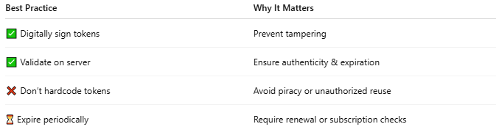

Best Practice | Why It Matters
✅ Digitally sign tokens | Prevent tampering
✅ Validate on server | Ensure authenticity & expiration
❌ Don’t hardcode tokens | Avoid piracy or unauthorized reuse
⏳ Expire periodically | Require renewal or subscription checks

📌 Summary
# Source: AI Source: Provided by: [Data Path: Persons Table -> ID Column: 1, Name_En Column: Motasem Essam] -> From: [ChatGPT] on [1/18/2026]
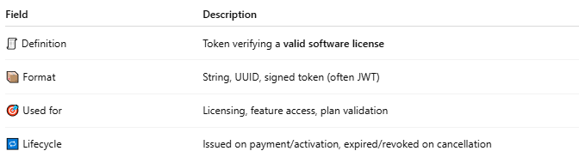

Field | Description
🧾 Definition | Token verifying a valid software license
📦 Format | String, UUID, signed token (often JWT)
🎯 Used for | Licensing, feature access, plan validation
🔁 Lifecycle | Issued on payment/activation, expired/revoked on cancellation

